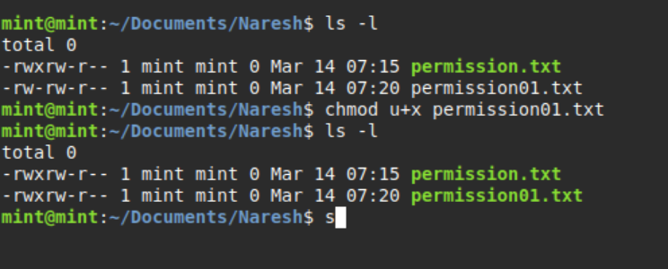

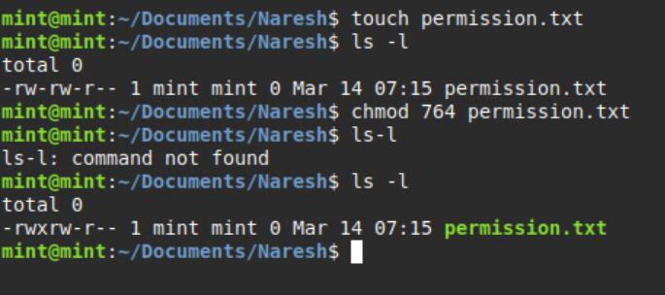

|  |  |
| --- | --- |
| **Access level** | **Octal value** |
| Read | 4 |
| Write | 2 |
| Execute | 1 |